

1.Project Report:

Title- Finance system

Course- vityarthi project

Student name- Prakhar Paliwal

Faculty name- DR Monika Vyas

Registration no-25BCE10523

Instituition- VIT Bhopal University

Year-2025

1.5.INDEX
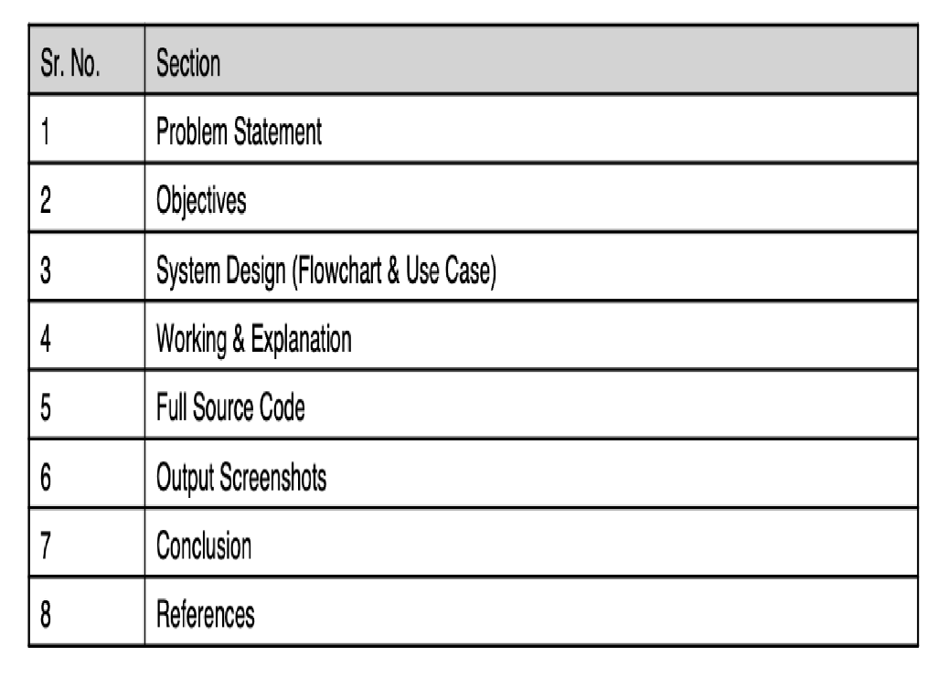

2. Introduction/Objectives
This is my very first project in python which shows how modules and libraries can be imported in python and how json dataset can be used to store data and help in finance system by adding expense showing balance and ease the life of consumers.

3. Problem Statement
The goal for this project is to finance expenses and help in better money management thus increasing savings and can lead to a better work life balance in user’s life used python libraries and modules and conditional statement to achieve this

4. Working and Explaination
This project uses command line finance tracking to track the user’s expense , total income , net balance, and this also stores the data in between the sessions for future reference.

It follows a modular design and is dividing the tasks –
- Main.py—application loop
- Storage.py—business logic
- Utils.py—contains utility function
- Services.py—handling persistence

Thus enabling the program as a whole to run together

5. Project source code
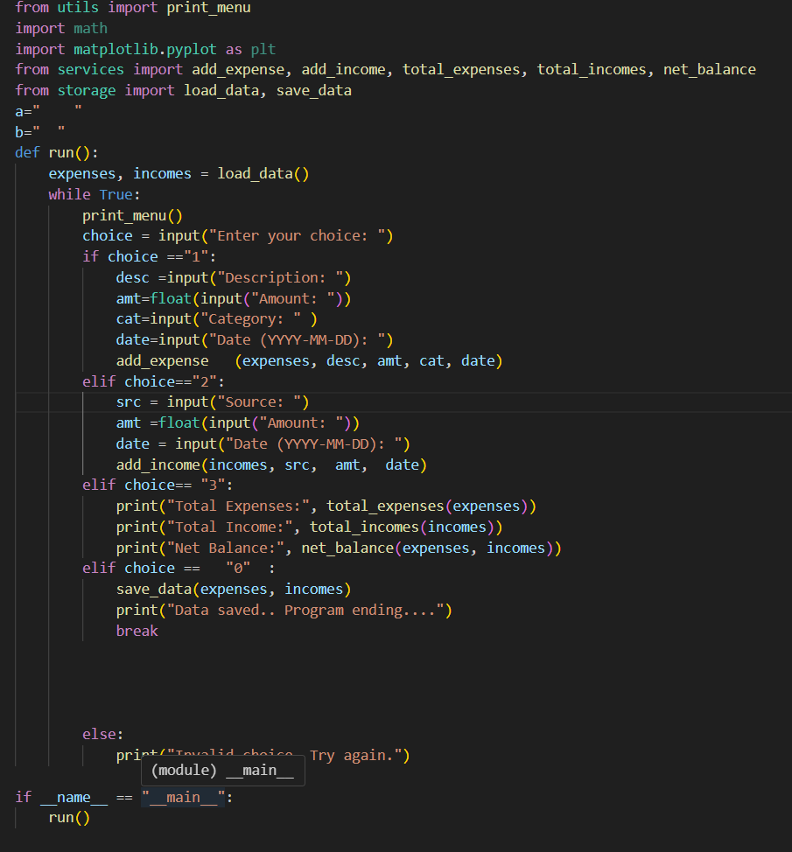

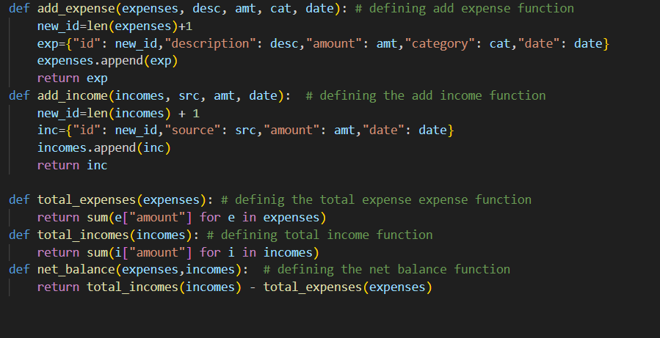

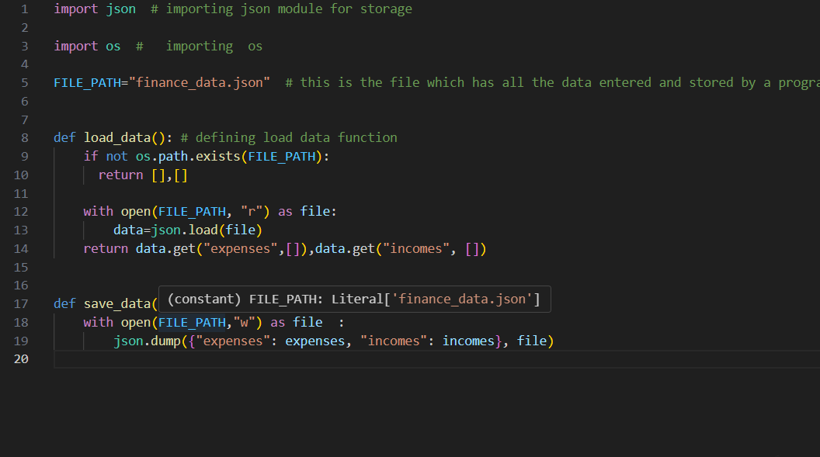

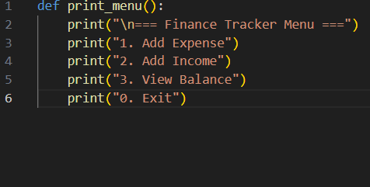

6. Implementation Details
This projects demonstrates the use of ai to successfully tackle a real life problem.The finance system management system covers data storage ,input validation and statistics. It is simple,lightweight and usefull for daily productivity.

7. Conclusion
**The program provides a core functionality which is very usefull for transactions and summary data

** it follows a modular design data persistency

** it has a light weight management system making it usefull in fast finance management and tracking

8. References

The user have took reference from the following concepts and logic—
•1 Python Code: It uses only basic Python commands.
• 2 Clean Setup: The code is split into small files, so each part has one job (like calculating or saving).
• 3 Data Storage: It holds all your records in simple lists.
• 4 Saving: It uses JSON to write the data to a file so it's not lost.

